Team Members:

Briana Sanchez (bsanchez12@miners.utep.edu)

Stephanie Medina (smedina7@miners.utep.edu)

Luisana Clarke (lclarke@miners.utep.edu)

Rocio Cardona (rcardona4@miners.utep.edu)

Bianca Alvarez (bsalvarez@miiners.utep.edu)

Dima Abdel Jaber (deabdeljaber@miners.utep.edu)

Abstract

This DVS Testing Document will contain information about tests being performed by team members throughout each iteration. This document will help to keep track of tests and allows us to address concerns the client has.

DVS Testing Document

Team Girls? Team B

Iteration # 3

## Load Testing

|  |  |  |  |  |
| --- | --- | --- | --- | --- |
| **Size of File** | **ECELD-Wireshark response** | **DVS Response** | **Throughput response** | **Comments** |
| **0.0022 GB** | 3.71 sec | 1.31 sec | 1.52 sec | No issues |
| **0.092 GB** | 1.46 sec | 0.43 sec | 1.07 sec | No issues |
| **0.145 GB** | 1.10 sec | 0.27 sec | 0.39 sec | No issues |
| **0.320 GB** | 6.66 sec | 0.73 sec | 6.82 sec | No issues |
| **1.616 GB** | 41.37 sec | 0.79 sec | 43.11 sec | No issues |
| **3.114 GB** | 68.16 sec | 0.93 sec | 69.73 sec | No issues |

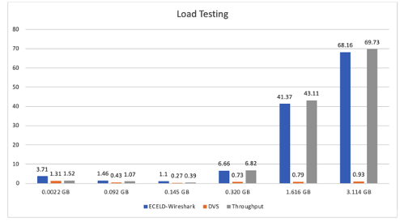

Iteration # 4

## Load Testing

|  |  |  |  |  |
| --- | --- | --- | --- | --- |
| Size of File | ECELD-Wireshark response | DVS Response | Throughput response | Comments |
| 0.0022 GB | 1.26 sec | 0.36 sec | 12.55 sec | No issues |
| 0.092 GB | 1.43 sec | 0.43 sec | 12.17 sec | No issues |
| 0.145 GB | 1.92 sec | 0.47 sec | 12.39 sec | No issues |
| 0.320 GB | 6.54 sec | 0.63 sec | 12.24 sec | No issues |
| 1.616 GB | 67.91 sec | 1.92 sec | 12.29 sec | No issues |
| 3.114 GB | 74.13 sec | 0.93 sec | 12.33 sec | No issues |

